Chapter 3 Transport Layer
- Transport-layer services
Role of Transport Services & Protocols
- Provide logical communication between application processes on different hosts.
- Operate on top of the network layer.
- sender: breaks application messages into segments, passes to network layer
- receiver: reassembles segments into messages, passes to application layer
Transport Layer vs. Network Layer
- Transport Layer: Communication between processes (end-to-end).
- Network Layer: Communication between hosts.
Transport Layer Actions
Sender Side:
- Receives the message from the application layer.
- Segments the message into smaller units and attaches transport layer headers containing control information (e.g., sequence numbers, source and destination port numbers).
- Multiplexes segments from multiple application processes by assigning unique source port numbers, allowing multiple connections to share the same network layer.
- Forwards each segment to the IP layer (network layer) for transmission.
Receiver Side:
- Accepts incoming segments from the IP layer.
- Verifies the integrity and correctness of header fields (e.g., checksum, sequence number).
- Reassembles segments in the correct order to reconstruct the original application message.
- Demultiplexes the received segments by examining destination port numbers, delivering the data to the correct application process via sockets.

Internet Transport Protocols
- TCP (Transmission Control Protocol)
  - Reliable, in-order delivery.
  - Flow control & congestion control.
  - Connection-oriented (setup required).
- UDP (User Datagram Protocol)
  - Unreliable, unordered delivery.
  - Lightweight, minimal overhead.
  - No flow/congestion control.
Services Not Provided by Transport Layer
- Delay guarantees.
- Bandwidth guarantees.

Types of Demultiplexing
A. Connectionless Demultiplexing (UDP)
- Identification: UDP socket is identified by destination IP address + destination port number only. (Socket)
- When a UDP segment arrives:
  - Host checks the destination port #.
  - Directs UDP segment to the socket bound to that port.
- Multiple sources can send to the same destination port → all data delivered to the same socket.
Example:
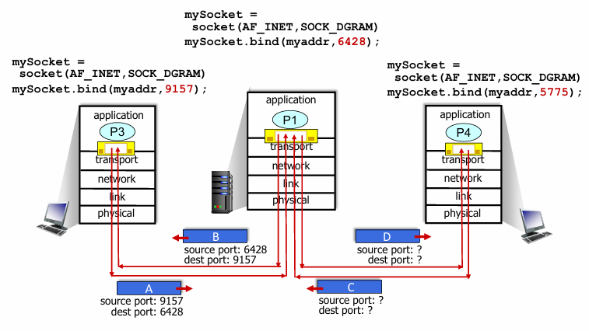
Key Point (Concise):
- UDP datagrams with the same destination port go to the same socket, regardless of source IP/port.

B. Connection-Oriented Demultiplexing (TCP)
- Identification: TCP socket is identified by a 4-tuple:
  - Source IP address
  - Source port number
  - Destination IP address
  - Destination port number
- Receiver uses all 4 values to direct segment to the correct socket.
- A server can support many simultaneous TCP sockets:
  - Each connection has a unique 4-tuple.
  - Allows multiple clients to connect to the same server/port (e.g., port 80 for HTTP).
Example:
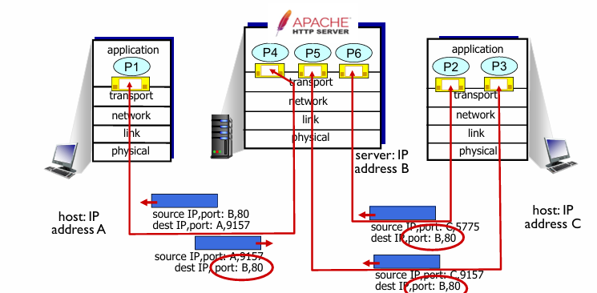
Feature | Connection-Oriented Demultiplexing | Connectionless Demultiplexing
Protocol Example | TCP | UDP
Demultiplexing Key | Connection identifier: combination of <src IP, src port, dest IP, dest port> (4-tuple) | Destination port (and optionally dest IP) only (2-tuple)
State Maintained | Per-connection state (e.g., sequence numbers, buffers) | No per-connection state at receiver
Packet Delivery | Delivered to the correct established connection | Delivered to the process listening on the destination port
Reliability | Can provide reliable, ordered delivery | No reliability; packets may arrive out-of-order or be lost
Use Case | TCP sessions (HTTP, FTP, SSH) | UDP messages (DNS queries, streaming, DHCP)

- Connectionless transport: UDP
Why Use UDP?
- No delay from connection setup.
- Minimal overhead.
- Good for apps that tolerate some loss but need low delay.
Common Uses - Streaming multimedia.
Reliability and Congestion Control
- UDP itself doesn’t provide these.
- Apps like HTTP/3 add reliability and congestion control on top.
UDP: Transport Layer Actions
UDP Sender Actions
- Receives a message from the application layer (e.g., SNMP client).
- Sets UDP header fields (source port, destination port, length, checksum).
- Creates a UDP segment by combining header and message.
- Passes the UDP segment down to the IP layer for transmission.
UDP Receiver Actions
- Receives UDP segment from the IP layer (e.g., at SNMP server).
- Checks UDP checksum to verify data integrity.
- Extracts the application-layer message from the UDP segment.
- Uses the destination port to demultiplex and deliver the message to the correct application via the socket.
UDP Checksum - Detect errors (like flipped bits) in the transmitted UDP segment.
How It Works
Sender Side:
- Treats the UDP segment (header + data) and IP addresses as a series of 16-bit numbers.
- Adds these numbers using one’s complement addition to get a checksum value.
- Places this checksum value into the UDP header’s checksum field.

Receiver Side:
  - Computes the checksum over the received segment the same way.
  - Compares the computed checksum with the checksum field in the segment:
    - If not equal → error detected (data corrupted).
    - If equal → no error detected (but some errors may still go unnoticed, see advanced details).
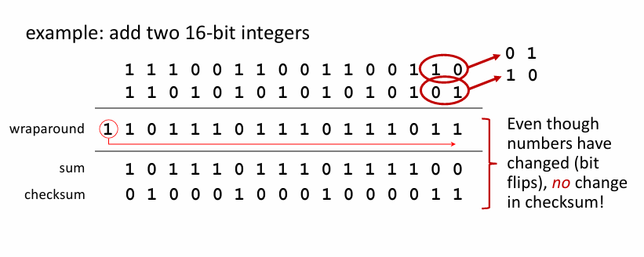
- Principles of reliable data transfer
The Problem
- The network (channel) is unreliable — packets can get lost, corrupted, or arrive out of order.
- The sender and receiver don’t automatically know if the other got the message — they need to communicate about it.
How Reliable Data Transfer Works
Reliable service abstraction makes an unreliable network look reliable to applications.
- Sender side:
- Gets data from the application.
- Sends it over the unreliable network.
- Waits for confirmation (like a “Got it!” message) from the receiver.
- Receiver side:
- Receives data from the network.
- Checks if data is correct (not corrupted).
- Sends an acknowledgment back to the sender.
- Passes the data up to the application.
- If something goes wrong:
  - The sender will resend the data until it gets confirmation.
Key Points
- The complexity depends on how bad the channel is (losing packets, errors, etc.).

- Reliable data transfer protocol (rdt): interfaces
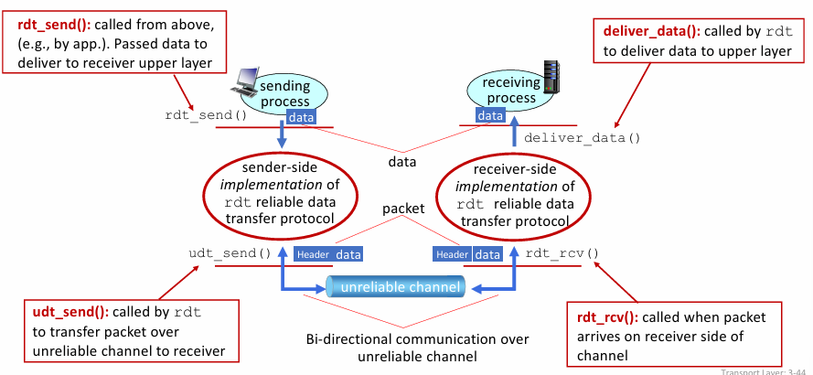
- Reliable data transfer: getting started
We will:
- Incrementally develop sender, receiver sides of (rdt)
- consider only unidirectional data transfer but control info will flow in both directions.
- rdt1.0: reliable transfer over a reliable channel
Assumptions: Channel is perfect (no errors, no loss, no duplicates).
Behaviours:
- Sender sends packet.
- Receiver gets it and delivers it.
- No ACKs, no error checking.
Limitations:
- Unrealistic for real networks (real networks have errors).
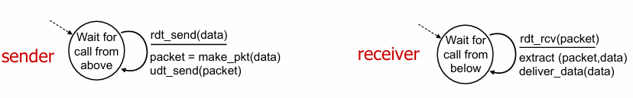

- rdt2.0: Reliable transfer over a channel with bit errors
- New Problem: Channel may corrupt bits in the packet.
- Solution: Use checksums to detect errors.
  - Receiver sends:
    - ACK if packet is correct. receiver explicitly tells sender that pkt received OK
    - NAK if packet is corrupted. receiver explicitly tells sender that pkt had errors
  - Sender resends if NAK is received.
    - stop and wait sender sends one packet, then waits for receiver response
- Limitations:
  - What if ACK or NAK is lost or corrupted?
    - sender doesn’t know what happened at receiver!
    - can’t just retransmit possible duplicate
  - Can lead to confusion and duplicates.

- rdt2.1: Handles corrupted ACKs/NAKs using sequence numbers
- Problem addressed: ACK/NAK corruption issue in rdt2.0.
Sender
- Adds a sequence number (seq #) to each packet.
- Only 2 sequence numbers (0 and 1) are enough.
  - Why? Because at most one packet can be “in flight” at a time. (Unidirectional flow of data)
  - So, we only need to distinguish between current packet and previous packet.
- Must check if ACK/NAK received is corrupted.
- States: Twice as many as rdt2.0 because the sender must remember whether the next packet should have seq # 0 or 1.
Receiver
- Must check if received packet is a duplicate.
- Maintains state: which seq # (0 or 1) is expected next.
- Limitation: Receiver cannot know if its last ACK/NAK was successfully received by the sender.

- rdt2.2: Improved version without NAKs
Goal: Remove the use of NAKs (negative acknowledgments).
How it works
- Receiver sends ACKs only.
- Instead of sending a NAK for corrupted/missing packets, the receiver repeats ACK for last successfully received packet.
- Sender behaviour:
  - Duplicate ACK = retransmit current packet.
- This is the principle used by TCP (NAK-free).
Sender & Receiver
- Sender: tracks seq number, retransmits on duplicate ACK.
- Receiver: tracks expected seq number, sends ACK for last correct packet received.

- rdt3.0: Reliable Data Transfer with Loss and Corruption
New assumption: Channel can lose packets (data or ACKs), in addition to corruption.
Challenge
- Corruption + loss → simple ACK/NAK not enough.
Solution
- Timeouts:
- Sender waits a “reasonable” amount of time for ACK.
- If timeout expires → retransmit the packet.
- Sequence numbers handle duplicates:
  - If packet is delayed but not lost, retransmission may create duplicates.
  - Receiver can detect and discard duplicates.
- ACKs include seq # of the packet being acknowledged.
Intuition / Analogy
- Think of a conversation: if the listener doesn’t respond, the speaker repeats the last word.
- Sequence numbers are like labeling each word “1, 2, 1, 2…” so both sides know which word is new and which is a repeat.

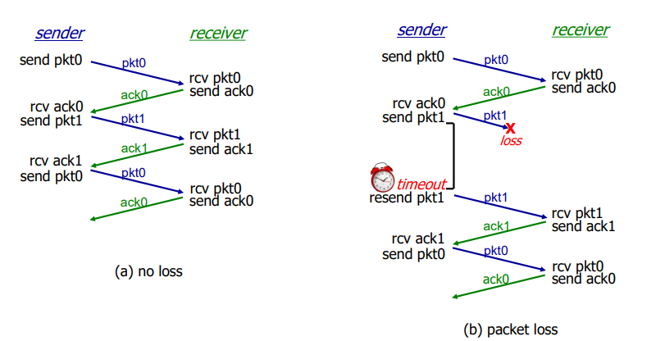
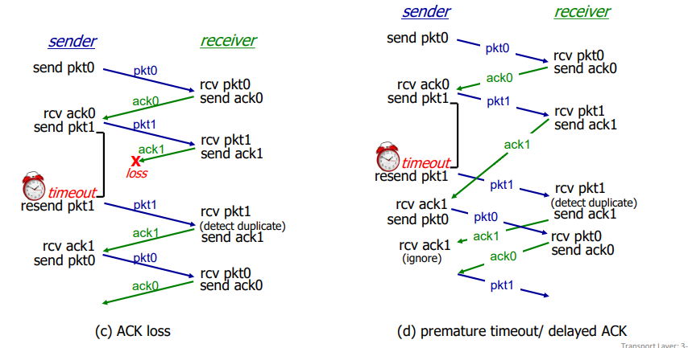
Performance of rdt3.0 in Stop and wait Protocol
U sender: utilization – fraction of time sender busy sending
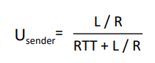
Pipelining:
- sender allows multiple, “in-flight”, yet-to-be-acknowledged packets
- range of sequence numbers must be increased
- Buffering at sender and/or receiver
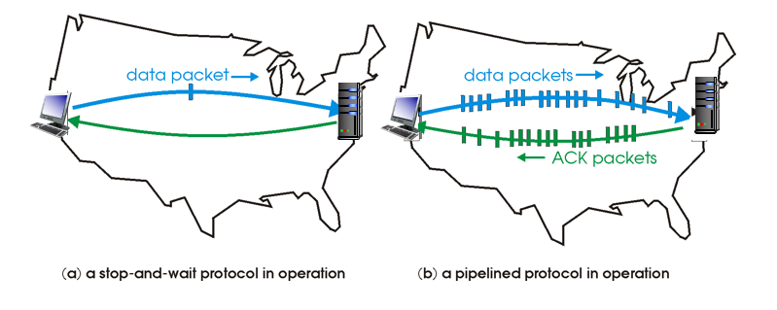
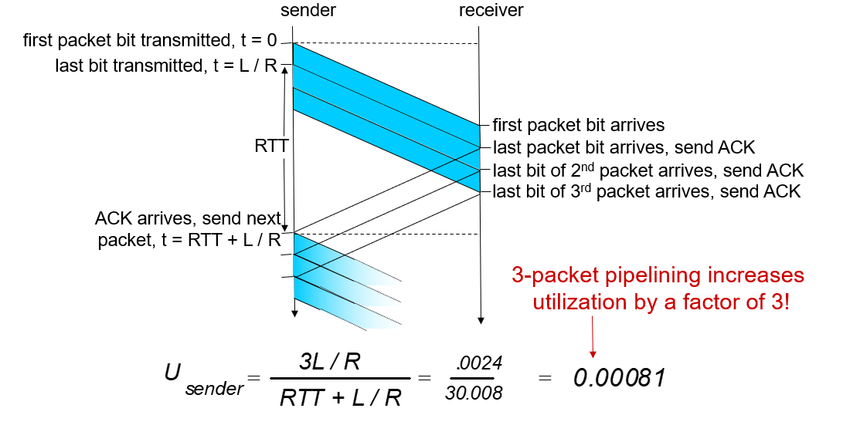
- Go-Back-N:
1. Sender Side
Goal: Send multiple packets efficiently while ensuring reliable delivery.
Key Features
- Sliding Window
  - Sender can have up to N consecutive unACKed packets “in flight.”
  - Each packet has a k-bit sequence number in the header.
- Cumulative ACKs
  - Receiver sends ACK(n) → acknowledges all packets ≤ n.
  - Sender moves the window forward to start at n+1.
- Timer
  - Only oldest in-flight packet is timed.
- Timeout / Retransmission
  - If timer expires for packet n, sender retransmits packet n and all higher seq # packets in the window.
Intuition:
- Window lets sender keep the network “full.”
- Cumulative ACKs reduce feedback overhead.
- Retransmitting all after a loss ensures nothing is missed.

2. Receiver Side
Goal: Ensure reliable, in-order delivery to the application.
Key Features
- ACK-only
  - Always ACK the highest in-order packet received (rcv_base).
  - May generate duplicate ACKs if out-of-order packets arrive.
- Out-of-Order Packets
  - Option 1: Discard them (simplest, classic GBN).
  - Option 2: Buffer them (implementation choice).
  - Always re-ACK the highest in-order seq # received.
- State
  - Only needs to remember rcv_base → next expected seq #.
Intuition:
- Receiver ensures in-order delivery by focusing on the next expected packet.
- Duplicate ACKs help sender know where loss occurred.
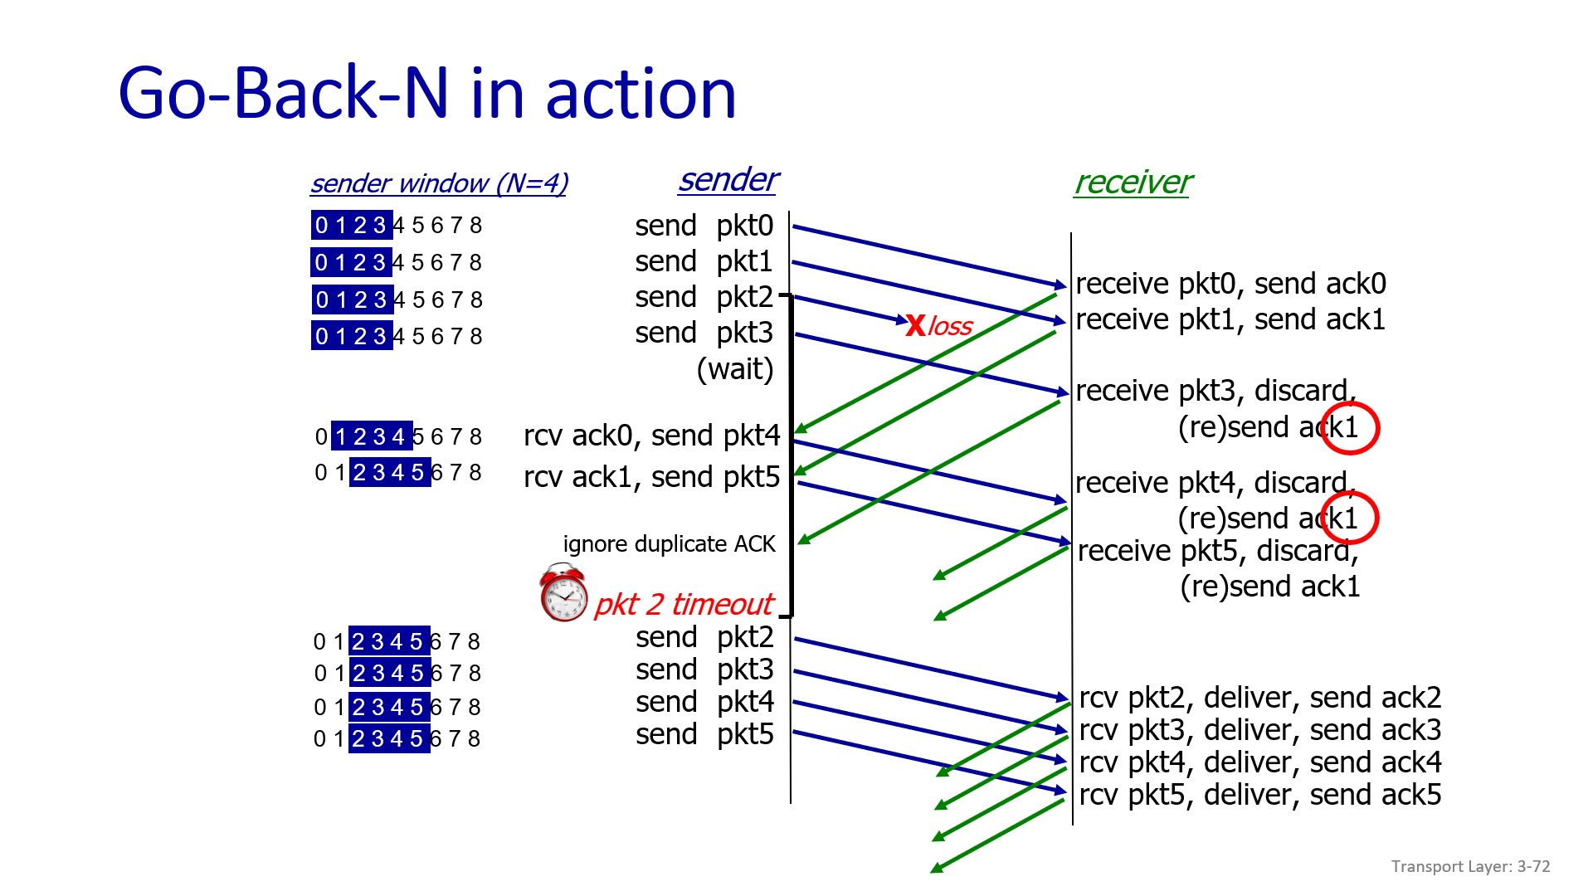
- Selective repeat
1. Key Idea
- Goal: Reliable, pipelined delivery over unreliable channels.
- Unlike Go-Back-N, SR retransmits only the lost packets, not all packets after a loss.
2. Pipelining
- Multiple packets in flight at the same time.
- Sender maintains a window of up to N consecutive sequence numbers.
- Receiver also maintains a window of N sequence numbers for expected packets.
3. Receiver Behavior
- Individual ACKs:
  - ACK every correctly received packet individually.
- Buffering:
  - If a packet is out-of-order, buffer it until missing packets arrive.
  - If a packet is in-order, deliver it to the upper layer and any buffered consecutive packets.
- ACK handling:
  - Packet n in [rcv_base, rcv_base+N-1] → ACK(n)
  - Packet n in [rcv_base-N, rcv_base-1] → duplicate ACK(n)
  - Otherwise → ignore
4. Sender Behavior
- Window: Conceptual window of N consecutive seq #s.
  - Only packets in this window can be sent (“in-flight”).
- Timers:
  - Each unACKed packet has its own timer.
  - On timeout(n) → retransmit only packet n and restart its timer.
- Receiving ACKs:
  - ACK(n) in [send_base, send_base+N-1] → mark packet n as received.
  - If n is the smallest unACKed packet, advance window base to next unACKed seq #.
  - Otherwise → just mark packet as received (no window shift).

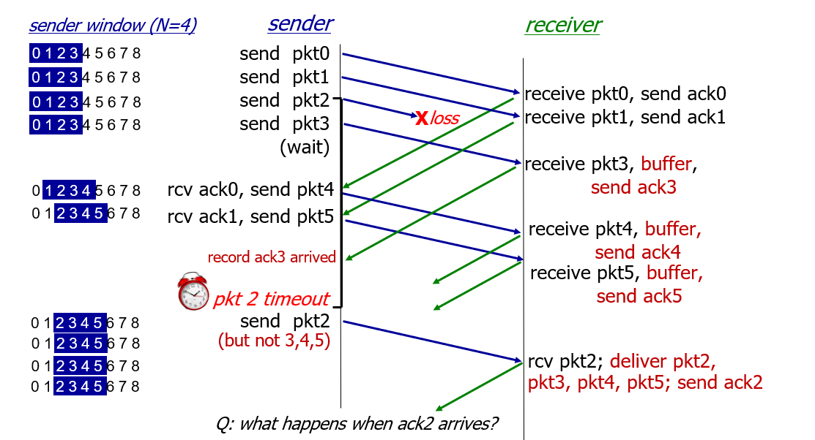
- Connection-oriented transport: TCP (Done)
- Point-to-point: One sender, one receiver.
- Reliable, in-order byte stream: No message boundaries.
- Full duplex: Data flows both directions simultaneously.
  - MSS (Maximum Segment Size): Largest data chunk in a TCP segment.
- Cumulative ACKs: A single ACK confirms receipt of all earlier bytes.
- Pipelining: Multiple packets in transit, controlled by:
  - Flow control (receiver capacity)
  - Congestion control (network capacity)
- Connection-oriented: Uses handshaking to establish connection.
- Flow-controlled: Sender avoids overwhelming receiver buffer.
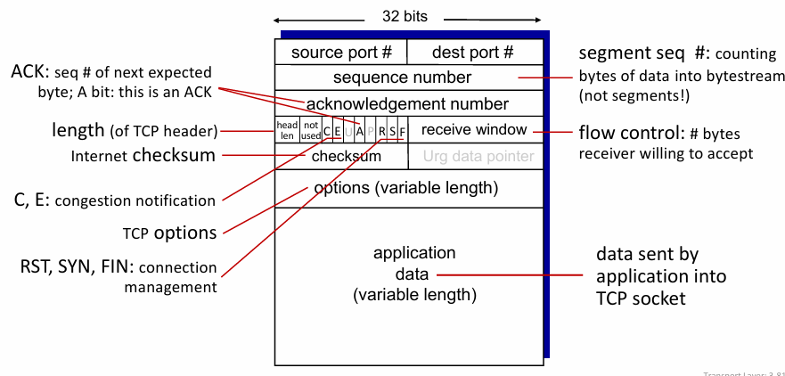
Sequence Numbers:
- Represent the byte number of the first byte in a segment’s data.
Acknowledgments (ACKs):
- Indicate the sequence number of the next byte expected from the sender.
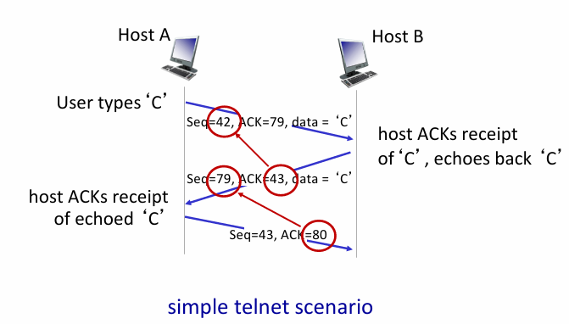
TCP Round Trip Time (RTT) & Timeout
How to set TCP timeout value?
  - Timeout must be longer than RTT.
  - But RTT varies over time.
  - If timeout is too short → premature timeout → unnecessary retransmissions.
  - If timeout is too long → slow to detect loss → slow recovery.
How to estimate RTT?
  - Measure SampleRTT: time from sending a segment until receiving its ACK.
  - Ignore retransmissions when measuring SampleRTT.
  - To smooth out variation, use an Estimated RTT by averaging several recent SampleRTT values (e.g., weighted moving average).
EstimatedRTT = (1- α)*EstimatedRTT + α*SampleRTT α = 0.125
TimeoutInterval = EstimatedRTT + 4*DevRTT DevRTT = safety margin
DevRTT = (1-β)*DevRTT + β*|SampleRTT-EstimatedRTT| β = 0.25
TCP Sender Events (Simplified)
- Data from Application:
  - Create segment with sequence number (byte number of first data byte).
  - If timer isn’t running, start it (tracks oldest unACKed segment).
  - Timer set to TimeoutInterval.
- Timeout Event:
  - Retransmit the segment that timed out.
  - Restart the timer.
- ACK Received:
  - If ACK covers new unACKed segments, update ACKed data.
  - If unACKed segments remain, restart the timer.
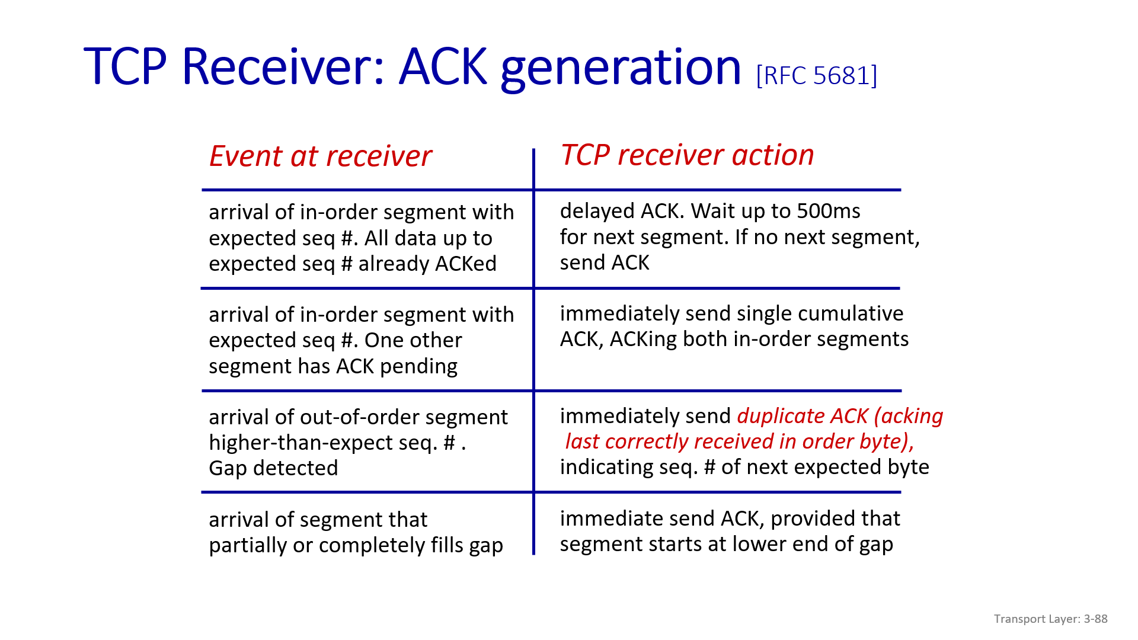
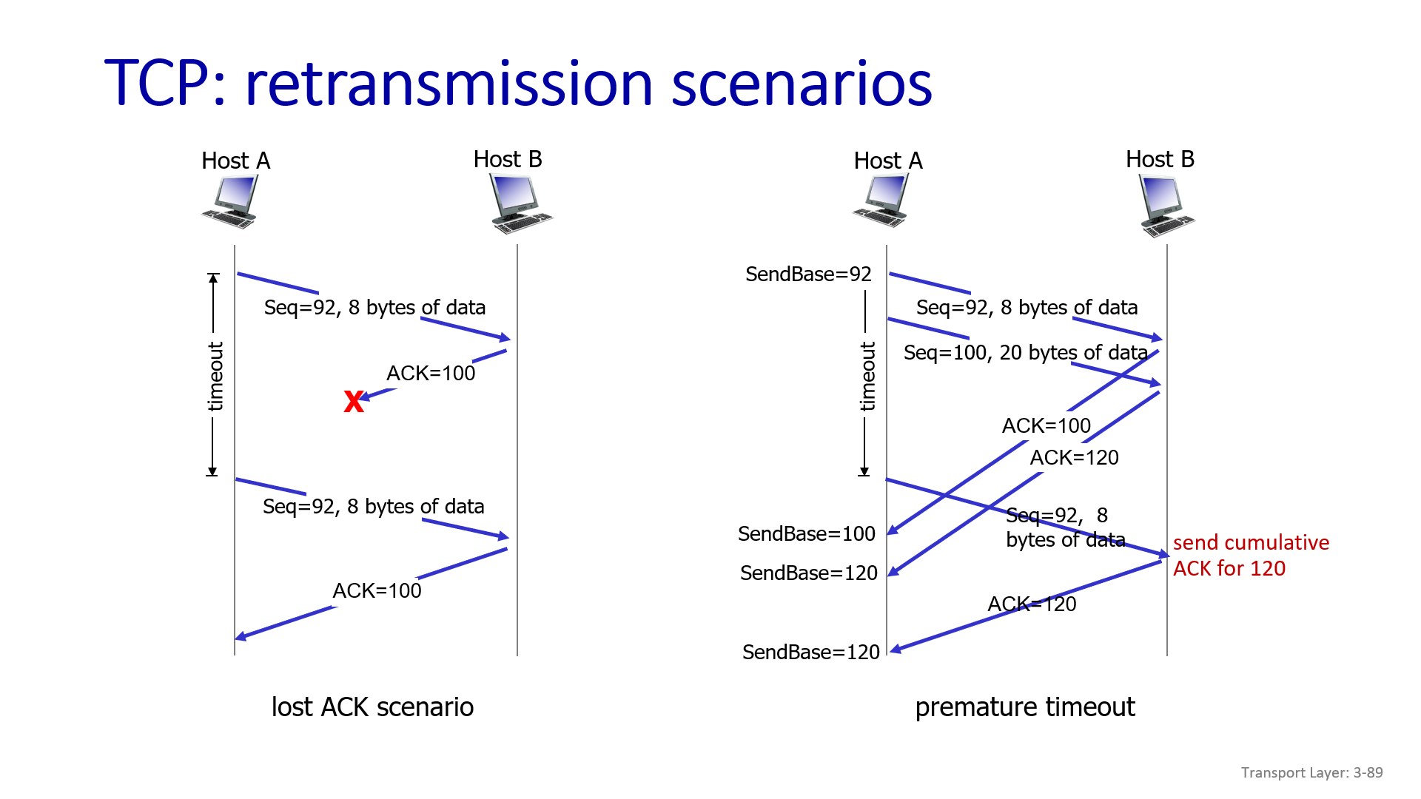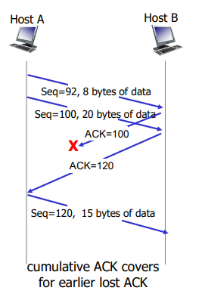
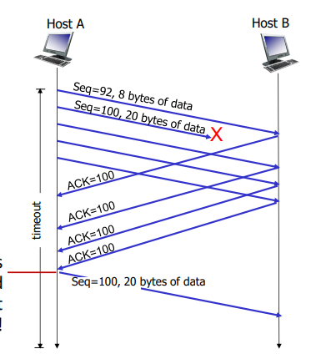
TCP Fast retransmit
Fast Retransmission in TCP
- Normally, retransmission happens after a timeout (RTO). But timeouts are costly because they delay recovery.
- To recover faster, TCP uses duplicate ACKs as a signal.
🔹 How it works
- Sender sends segments: 1, 2, 3, 4, 5.
- Suppose segment 2 is lost.
- Receiver gets segment 1 (ACK=2 expected), then gets 3, 4, 5 — but can’t advance ACK because 2 is missing.
- So, receiver keeps sending ACK=2 (duplicate ACKs).
- Sender receives 3 duplicate ACKs for 2 in a row.
- Sender concludes: “Segment 2 is missing → retransmit immediately!”
- Sender retransmits segment 2 without waiting for RTO.
- Receiver gets 2, now sends ACK=6 (since 1–5 are all complete).
🔹 Why 3 duplicate ACKs?
- A single duplicate ACK could be caused by out-of-order delivery, not actual loss.
- Waiting for 3 duplicate ACKs provides a balance between responsiveness and false alarms.
🔹 Fast Retransmit + Fast Recovery
- After fast retransmit, TCP often enters fast recovery (instead of slow start), adjusting congestion window (cwnd) more smoothly.
- This avoids dropping throughput too drastically.

- Principles of congestion control
TCP flow control
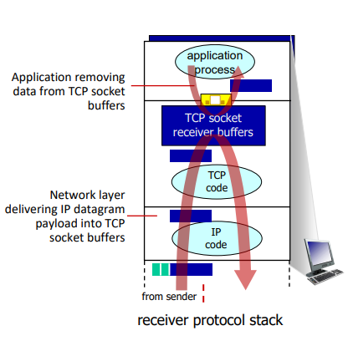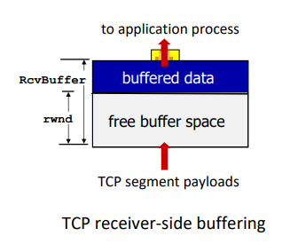

🔹 TCP Flow Control (Receiver-Driven)
- Purpose: Prevent the sender from overwhelming the receiver’s buffer.
- Mechanism: Receiver explicitly tells the sender how much buffer space it has available using the rwnd (receive window) field in the TCP header.
🔹 How it Works
- Receiver Buffer
  - Receiver allocates a RcvBuffer (default often 4096 bytes, but adjustable via socket options).
  - Many modern OSes use auto-tuning to dynamically resize it depending on application speed and network conditions.
- Advertising Window (rwnd)
  - Receiver tracks free space in buffer.
  - Sends this value in every ACK → “I can accept rwnd more bytes.”
- Sender Behavior
  - Sender calculates:
Allowed in-flight data≤rwnd
  - Ensures unACKed data never exceeds receiver’s advertised window.
- Zero Window Advertisement (ZWA)
  - If buffer is full → receiver advertises rwnd = 0.
  - Sender must pause sending new data.
  - Sender occasionally sends window probes to check if space has freed up.
- Guarantee
  - Because sender limits in-flight data ≤ rwnd, receiver’s buffer will never overflow.
  - Flow control is thus receiver-driven safety.

TCP Connection management
- Before sending data, TCP endpoints must establish a connection.
- Goals of handshake:
  - Agree that both sides are willing to communicate.
  - Exchange initial sequence numbers (ISN).

🔹 2-Way Handshake
- Step 1: Sender → Receiver: SYN (request connection, seq=x)
- Step 2: Receiver → Sender: SYN-ACK (ack=x+1, seq=y)
✅ At this point, both sides can start sending data.

Problems with 2-way
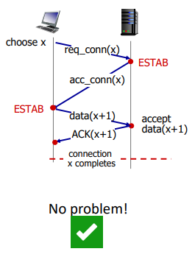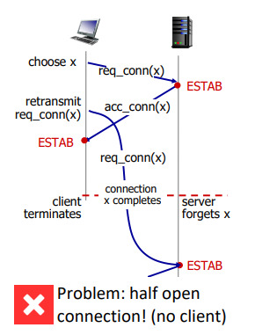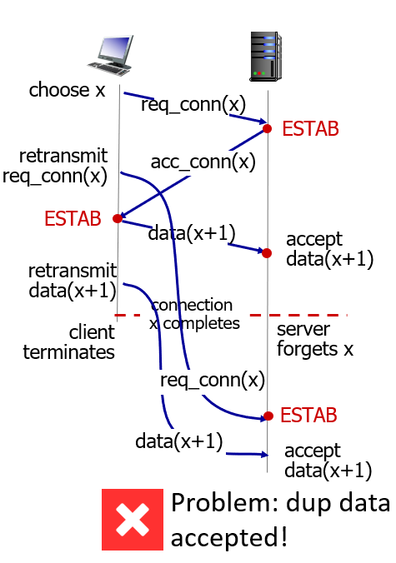
Three way handshake
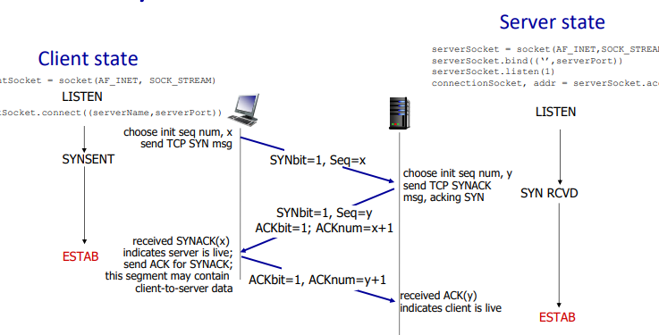
Step | Sender/Client → Receiver/Server | Explanation
1. SYN | Client → Server: SYN, seq=x | Client requests connection and proposes its initial sequence number (ISN).
2. SYN-ACK | Server → Client: SYN, seq=y; ACK=x+1 | Server acknowledges client’s SYN (ACK=x+1) and sends its own SYN with server ISN=y.
3. ACK | Client → Server: ACK=y+1 | Client acknowledges server’s SYN. Connection is now established and both sides know each other’s ISNs.
Closing Connection
- FIN → Sender wants to stop sending.
- ACK ← Receiver acknowledges FIN.
- FIN ← Receiver finishes sending.
- ACK → Sender acknowledges receiver’s FIN.
Result: Connection fully closed.
- Half-close: After step 2, one side can’t send, but can still receive.
- TIME_WAIT: Ensures all packets are safely handled before releasing resources.

- TCP congestion control
Principles of congestion control
Aspect | Congestion Control | Flow Control
Purpose | Prevent network overload | Prevent receiver buffer overflow
Who controls | Network (routers) indirectly | Receiver controls sender
Symptoms | Packet loss, long delays | Sender blocked by receiver window
- Definition: Too many sources sending too much data too fast for the network to handle.
- Observable effects:
  - Long delays (queues build up in router buffers) -> Higher RTT
  - Packet loss (buffers overflow at routers) -> wastage of bandwidth
🔹 Causes / Costs — Simple Scenario - 1 (Ideal one)
- Setup:
  - One router have infinite buffers
  - Input/output link capacity = R
  - Two flows sharing the router
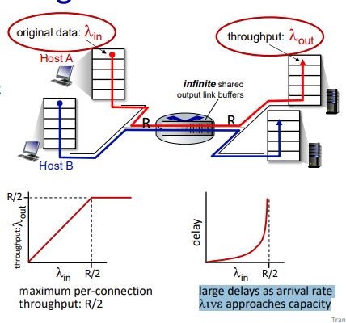
lamda in – data sent from sender lamda_out – reached at revciever (Throughput)
- Analysis:
  - Throughput get max at R/2 then constant.
  - Delay exponential increases as we reach Lambda_in as R/2
- Observation: Even if buffers are large, delays grow as utilization approaches link capacity.
🔹 Causes / Costs — Simple Scenario - 2 (Ideal one)
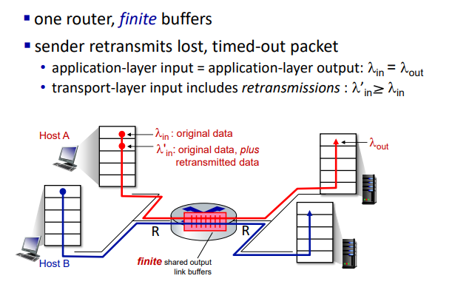
Case – a when perfect knowledge – Sender sends only when router buffer in available.
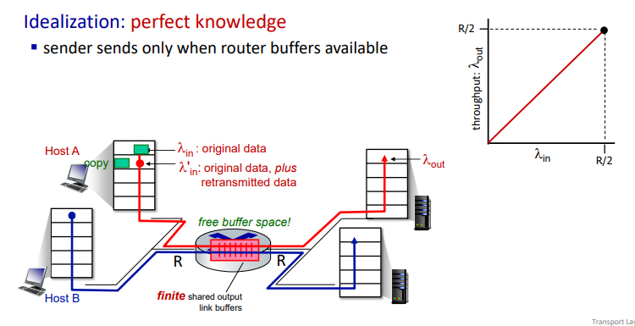
Case – b when some perfect knowledge –
- packets can be lost (dropped at router) due to full buffers
- sender knows when packet has been dropped: only resends if packet known to be lost
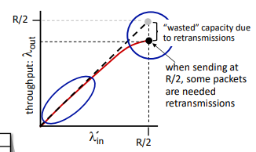
Case – C when un-needed duplicates–
- packets can be lost (dropped at router) due to full buffers
- but sender times can time out prematurely, sending two copies, both of which are delivered
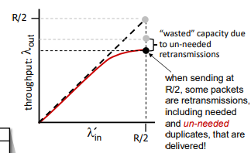
“costs” of congestion:
  - ▪ more work (retransmission) for given receiver throughput
  - ▪ unneeded retransmissions: link carries multiple copies of a packet
      - decreasing maximum achievable throughput
🔹 Causes / Costs — Simple Scenario - 3 (Ideal one)
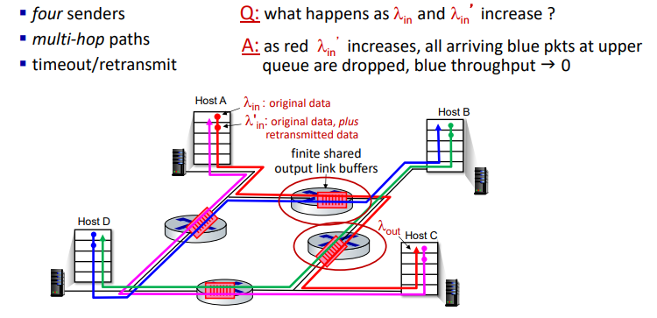
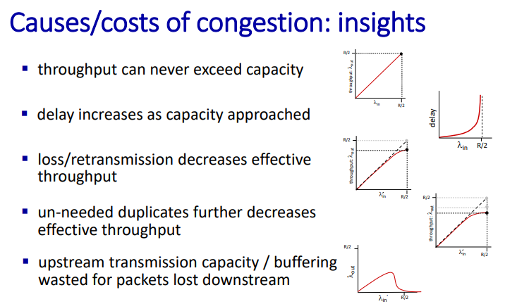
Aspect | End-to-End (TCP style) | Network-Assisted
Feedback | Implicit (loss, delay) | Explicit (routers tell hosts)
Deployment | No router support needed | Needs router cooperation
Example | TCP Reno, TCP NewReno | TCP ECN, DECbit, ATM ABR

TCP congestion control: AIMD
TCP sender trys to find fastest way to transmit the data
1. AIMD (Additive Increase, Multiplicative Decrease)
- Additive Increase:
  - Increase congestion window (cwnd) by +1 MSS per RTT.
  - Slowly probes for available bandwidth.
- Multiplicative Decrease:
  - On loss detected via 3 duplicate ACKs → cut cwnd to ½ (TCP Reno).
  - On loss via timeout → cwnd reset to 1 MSS (TCP Tahoe).
- Sawtooth behavior:
  - cwnd grows linearly, drops sharply on loss.
  - Repeats → "probe + backoff" cycle.
- Why AIMD?
  - Proven to fairly allocate bandwidth across flows.
  - Maintains network stability (avoids collapse).
2. TCP Sending Behavior
- Sender transmits up to cwnd bytes, then waits 1 RTT for ACKs.
- Sending rate ≈ cwnd / RTT (bytes/sec).
- 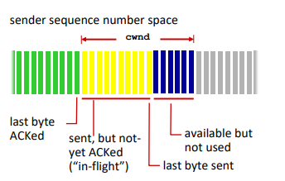
3. cwnd Adjustment Rules
- cwnd increases on successful ACKs (no congestion).
- cwnd decreases drastically on packet loss (sign of congestion).
- This balance prevents both underutilization and overload.
🚀 TCP Slow Start & Congestion Avoidance
Congestion Window - A TCP sender-side variable that controls how many bytes can be sent into the network before waiting for ACKs.
MSS (Maximum Segment Size) - largest chunk of application data (payload) that TCP can send
1. Slow Start Phase(Exponential growth till threshold)
- Initial cwnd = 1 MSS.
- For every ACK received → cwnd =cwnd + 1 MSS.
- Effect: cwnd doubles every RTT → exponential growth.
- Purpose: quickly ramp up transmission rate from idle.
2. Transition Point
- When cwnd ≥ ssthresh → switch to Congestion Avoidance.
- In Congestion Avoidance: (Additive increase)
  - cwnd grows linearly (≈ +1 MSS per RTT).
3. Handling Loss Events
- On packet loss: (Multiplicative decrease phase)
  - ssthresh = cwnd / 2 (just before loss).
  - If timeout → reset cwnd = 1 MSS (restart Slow Start).
  - If triple duplicate ACKs → cwnd = ssthresh (fast recovery, Reno).
4. Behavior Summary
- Start: Slow Start (exponential growth).
- After threshold: Congestion Avoidance (linear growth).
- On loss: cwnd drops, ssthresh updated, cycle continues.

TCP Congestion Control & TCP CUBIC – Simplified Notes
1. TCP Congestion Control Overview
- TCP increases its sending rate until packet loss occurs, which typically happens at the bottleneck link (the slowest link in the path).
- Goal: Keep the network pipe just full but avoid overloading (causing high delays or packet loss).
Key concepts:
- Bottleneck link: The link that limits throughput because it is busy most of the time.
- In-flight data (ninflight): Amount of data sent but not yet acknowledged.
- Bandwidth-Delay Product (BDP): Ideal amount of in-flight data for a connection
BDP = bandwidth × RTT
- TCP tries to maintain ninflight ≈ BDP to maximize throughput while avoiding congestion.
2. Classic TCP (TCP Reno / AIMD)
- Pros: Simple + Fairness among flows
- Cons:
  - Slow recovery to previous maximum throughput
  - May underutilize high-speed networks
Graph intuition:
- The window grows slowly, loses 50% at congestion, grows slowly again.
3. TCP CUBIC – Improved AIMD (Higher with average throughput)
TCP CUBIC is designed for high-speed and long-delay networks, improving throughput compared to classic TCP.
Key ideas:
- Wmax: Congestion window value at which packet loss occurred.
- K: Time at which window is expected to reach Wmax again.
- Cubic growth: Window increases as a cubic function of time relative to K.
cwnd (t ) = C⋅(t−K)^3 + Wmax
- Far from K → increase fast (aggressive)
- Near K → increase slow (cautious)
- Advantage: Quickly recovers to previous Wmax after loss, then grows slowly to probe safely.
Comparison:
Feature | Classic TCP | TCP CUBIC
Growth | Linear | Cubic
Recovery speed | Slow | Faster
Throughput | Lower | Higher

4. TCP Through Bottleneck Link
- Observation: Sending more than the bottleneck capacity does not increase throughput, it just increases queueing delay (RTT grows).
- Goal: Keep the bottleneck fully utilized but not overloaded.
- “keep the end-end pipe just full, but not fuller”
Multiple flows:
- N flows are executing own TCP Congestion control
- If N flows share a bottleneck of rate R, ideally each gets R/N.
Throughput vs In-flight data:
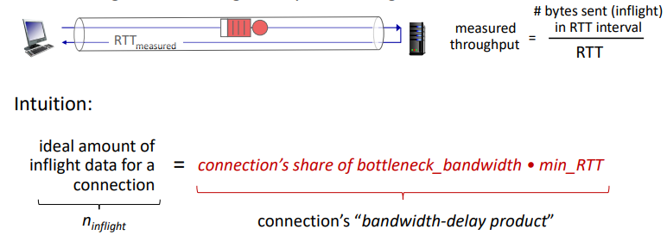
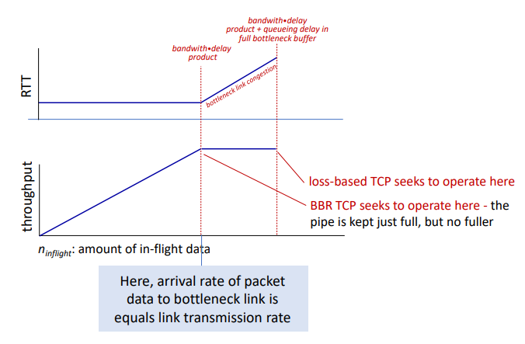
- If n_inflight < BDP → throughput can increase.
- If n_inflight ≈ BDP → link fully utilized, RTT stable.
- If n_inflight > BDP → queues grow, RTT increases.
5. Advanced TCP: BBR
- BBR (Bottleneck Bandwidth and RTT) is different from loss-based TCP:
  - Measures bottleneck bandwidth and minimum RTT.
  - Regulates in-flight data to keep pipe "just full".
  - Phases:
    - Acceleration: Increase sending rate until throughput plateaus.
    - Cruising: Send at measured throughput.
    - Deceleration: Reduce in-flight data to measure min RTT and avoid bufferbloat.
6. TCP Fairness
- Fairness goal: If K TCP sessions share a link of capacity R, each gets R/K.
- TCP Reno is fair only under ideal assumptions (same RTT, congestion avoidance phase, fixed sessions).
Exceptions
- Multimedia apps often use UDP → send at constant rate, tolerate packet loss → can be unfair to TCP flows.
- Web browsers may open multiple TCP connections → get more bandwidth than single connections.
7. ECN – Network-Assisted Congestion Control
- Explicit Congestion Notification:
  - Router marks IP header bits to indicate congestion (ECN).
  - Receiver echoes this in TCP ACK (ECE bit).
  - Sender reduces rate without waiting for packet loss.
  - involves both IP (IP header ECN bit marking) and TCP (TCP header C,E bit marking)
- Benefit: Reduces packet loss and bufferbloat.
- Evolution of transport-layer functionality
1. Traditional Transport Protocols
- TCP and UDP have been the main transport protocols for ~40 years.
- TCP “flavors” developed for specific scenarios:
Scenario | Challenges
Long, fat pipes | Many packets in flight; a single loss stalls pipeline
Wireless networks | Loss due to noise/mobility; TCP interprets as congestion
Long-delay links | Very large RTTs
Data center networks | Latency sensitive applications
Background traffic flows | Low-priority flows; avoid interfering with foreground traffic

2. Moving Transport Functions to Application Layer
- Modern applications increasingly implement transport-layer functions on top of UDP.
- Example: HTTP/3 uses QUIC.
3. QUIC (Quick UDP Internet Connections)
- Application-layer protocol built on UDP.
- Goals: Improve HTTP performance, reduce latency, support multiple streams.
- Deployed: Google services, Chrome, YouTube app, etc.
Key Features:
- Connection Establishment:
  - Reliable, secure, congestion-controlled connection in 1 RTT (or even 0 RTT).
- Error & Congestion Control:
  - Uses algorithms similar to TCP for loss detection and congestion control.
- Multiplexing:
  - Multiple application-level streams over a single QUIC connection.
  - Each stream is independent, reliable, and secure.
- Security:
  - Built-in encryption and authentication.
- Congestion Control:
  - Common control across all streams in a connection.

1. (6 points) Assume that a single TCP Reno connection uses a 10 Mbps bottleneck link that does not buffer any data. Assume that the TCP sender has a large file to send to the receiver and the receiver's receive buffer is much larger than that of the congestion window. The size of the TCP segment is 1250 Bytes and the RTT between the sender and the receiver is 10 msec. Considering only the congestion avoidance phase (ignore slow start phase), answer the following. What is the average window size (in segments) and average throughput (in bps) of this TCP connection? How long would it take for this TCP connection to reach its maximum window again after recovering from a packet loss (3 DupACKs)? a) TCP Reno, b) TCP Tahoe c) TCP Reno with 10 Gbps link in place of 10 Mbps link.
2. (6 points) When transferring the segments from the sender to the receiver, every 5% segment transmitted by the sender is lost in the network. Find the number of segments sent by the sender in order to successfully deliver 10 segments using both Go-Back-N and Selective Repeat ARQ mechanisms with a window size of 5. Asume that the ACKe are not lost in the network.
3. (6 points) Consider a TCP where the RTT of the connection is 100 msec and TCP Reno based congestion control mechanism is used. CWm and initial ssthres of the TCP connection are 2 MSS and 8 MSS, respectively. MSS of the TCP is 1KB. Ignore the HTTP header overhead and time to send the HTTP request. The browser downloads 3 web objects of size 50KB in sequence on this TCP connection.
(a) What is the time taken to download the first object? Assume tlast there is no plot loss during the download of the object
(b) What is the time taken to download the second object? Assume that there is no packet loss during the download of this object.
(c) What is the time taken to download the third object? Assume that there is a packet loss for the first TCP segment sent for this object which is detected by triple dupack.
4. (6 points) Assume a Telnet Connection between Host A and Host B. Host A sends each word typed by the user by identifying the "space" character and Host B echos the word back to Host A. Let the initial sequence number of Host A and Host B are 1000 and 2000, respectively. Specify the sequence number, ack number, ACK valid bit, and the Payload for each segment exchanged between Host A and Host B when the user in Host A types "ACN Tutorial your last name". Replace your last name with the string "your last name.

